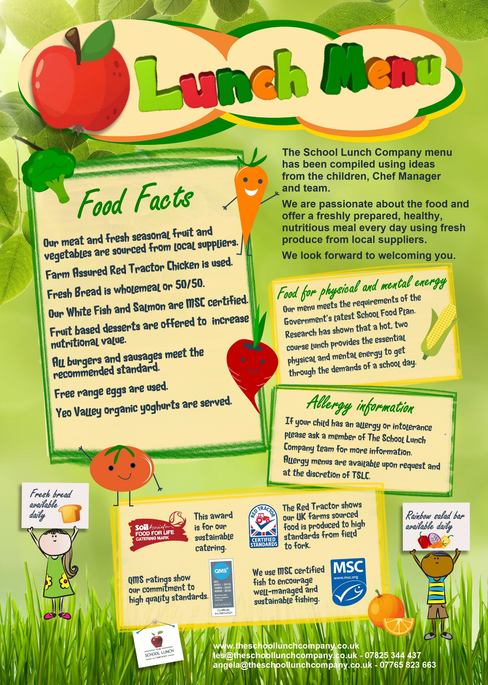
DRAFT PLEASE DO NOT DISTRIBUTE

SPRING/SUMMER

 | February |  |  |  |  |  | March |  |  |  |  |  | April |  |  |  |  |  | May |  |  |  |  |  | June |  |  |  |  |  | July |  |  |  |  |  | September
 | M | T | W | T | F |  | M | T | W | T | F |  | M | T | W | T | F |  | M | T | W | T | F |  | M | T | W | T | F |  | M | T | W | T | F |  | M | T | W | T | F
 |  |  | 1 | 2 | 3 |  |  |  | 1 | 2 | 3 |  | 3 | 4 | 5 | 6 | 7 |  | 1 | 2 | 3 | 4 | 5 |  |  |  |  | 1 | 2 |  | 3 | 4 | 5 | 6 | 7 |  | 3 | 4 | 5 | 6 | 7
 | 6 | 7 | 8 | 9 | 10 |  | 6 | 7 | 8 | 9 | 10 |  | 10 | 11 | 12 | 13 | 14 |  | 8 | 9 | 10 | 11 | 12 |  | 5 | 6 | 7 | 8 | 9 |  | 10 | 11 | 12 | 13 | 14 |  | 10 | 11 | 12 | 13 | 14
 | 13 | 14 | 15 | 16 | 17 |  | 13 | 14 | 15 | 16 | 17 |  | 17 | 18 | 19 | 20 | 21 |  | 15 | 16 | 17 | 18 | 19 |  | 12 | 13 | 14 | 15 | 16 |  | 17 | 18 | 19 | 20 | 21 |  | 17 | 18 | 19 | 20 | 21
 | 20 | 21 | 22 | 23 | 24 |  | 20 | 21 | 22 | 23 | 24 |  | 24 | 25 | 26 | 27 | 28 |  | 22 | 23 | 24 | 25 | 26 |  | 19 | 20 | 21 | 22 | 23 |  | 24 | 25 | 26 | 27 | 28 |  | 24 | 25 | 26 | 27 | 28
 | 27 | 28 |  |  |  |  | 27 | 28 | 29 | 30 | 31 |  |  |  |  |  |  |  | 29 | 30 | 31 |  |  |  | 26 | 27 | 28 | 29 | 30 |  | 31 |  |  |  |  |  | 31
ST KENELM’S PRIMARY SCHOOL Draft v3
 |  | Mindful Meatless Monday | Sugar Smart  Tuesday | Mid-Week Roast  Wednesday | Top Choice  Thursday | Fish-tastic  Friday
Week 1 | Main Option  1 | Baked Bean and Cheese Wrap | Minced Beef Bolognaise with Wholewheat Pasta Penne | Roast Turkey with Yorkshire Pudding and Gravy | Sausages with Mashed Potatoes and Gravy | MSC Oven Baked  Fish Fillet
 | Main Option  2 | BBQ Vegetarian Sausage Pizza | Vegetarian Lasagne | Cheese and Onion Parcel | Shepherdess Pie  (Savoury Vegetarian Mince topped with Mashed Potato) | Crispy Quorn Dippers
 | Veg | Herby Potatoes  Coleslaw  Peas | Garlic Bread Slice  Broccoli  Sweetcorn | Roast Potatoes  Seasonal Vegetables  Savoy Cabbage | Green Beans  Carrots | Chips or Pasta  Peas  Baked Beans
 | Main Option  3 | Baked Jacket Potato with a Choice of Filling | Baked Jacket Potato with a Choice of Filling |  | Baked Jacket Potato with a Choice of Filling
 | Dessert | Fresh Fruit / Yoghurt  Chocolate and Fruit Krispie Cake | Fresh Fruit / Yoghurt  Or  Fruit Salad | Fresh Fruit / Yoghurt  Or  Cherry and Oat Cookie | Fresh Fruit / Yoghurt  Or  Iced Carrot Cake | Fresh Fruit / Yoghurt  Or  Strawberry and Vanilla Mousse
Week 2 | Main Option  1 | Margherita Pizza with Herby Potatoes | Chicken Katsu Curry  with Rice  (Breaded Chicken in a Mild Curry Sauce) | Roast Gammon with Yorkshire Pudding and Gravy | Oven Baked  Beef Burger in a Soft Roll | MSC Oven Baked Fish Fingers or MSC Bubble Coated Salmon Fillet
 | Main Option  2 | Mild Bean Chilli  Served with Rice | Macaroni Cheese | Roast Vegan Quorn Sausages with Yorkshire Pudding | Oven Baked  Vegetarian Burger in a Soft Roll | Crispy Quorn Dippers
 | Veg | Sweetcorn  Carrots | Carrots  Broccoli | Roast Potatoes  Seasonal Vegetables  Cauliflower  Gravy | Jacket Wedges Coleslaw  Carrots | Chips or Pasta  Peas  Baked Beans
 | Main Option  3 | Baked Jacket Potato with a Choice of Filling | Baked Jacket Potato with a Choice of Filling |  | Baked Jacket Potato with a Choice of Filling
 | Dessert | Fresh Fruit / Yoghurt  Or  Chocolate Brownie | Fresh Fruit / Yoghurt  Or  Apple Flapjack | Fresh Fruit / Yoghurt  Or  St Clements Shortbread | Fresh Fruit / Yoghurt  Or  Sticky Toffee Pudding with Cream | Fresh Fruit / Yoghurt  Or  Iced Fruit Smoothie
Week 3 | Main Option  1 | Margherita Pizza | BBQ Beef Pasta  (BBQ Minced Beef served with Pasta) | Roast Chicken with Yorkshire Pudding and Gravy | All Day Breakfast | MSC Oven Baked Fish Fillet
 | Main Option  2 | Vegetarian Sausage Roll | Tomato and Mozzarella Pasta Bake with Crusty Bread | Roast Quorn with Yorkshire Pudding | Veggie All Day Breakfast | Crispy Quorn Dippers
 | Veg | Oven Baked Homemade Jacket Wedges  Peas  Sweetcorn | Green Beans  Carrots | Roast Potatoes  Seasonal Vegetables  Savoy Cabbage | Hash Browns  Baked Beans  Sweetcorn | Chips or Pasta  Peas  Baked Beans
 | Main Option  3 | Baked Jacket Potato with a Choice of Filling | Baked Jacket Potato with a Choice of Filling |  | Baked Jacket Potato with a Choice of Filling
 | Dessert | Fresh Fruit / Yoghurt  Or  Marble Sponge with Raspberries | Fresh Fruit / Yoghurt  Or  Fruit Salad | Fresh Fruit / Yoghurt  Or  Apple Muffin | Fresh Fruit / Yoghurt  Or  Jelly with Mandarins | Fresh Fruit / Yoghurt  Or  Ice Cream Roll

